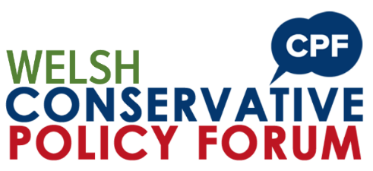

Consultation Response Form:
How to ensure Wales meets its Net Zero targets?

You can complete the consultation online at www.conservatives.wales/cpf or email this form to manifesto@conservatives.wales by midnight 27th August 2023.
Please complete your details below:
Name
Constituency
Email
Telephone
Question 1:
What do you believe are the biggest barriers to Wales meeting its net zero targets?
Answer:

Question 2:
In your opinion, is the planning system in Wales sufficient to deliver renewable energy projects?
Answer:

Question 3:
How can the Welsh Government take the people of Wales along with its net zero ambitions?
Answer:

Question 4:
Is education and/or training sufficient to enable and encourage young people to start careers in green energy, and if not how would you improve them?
Answer:

Question 5:
Do you believe that Wales will meet its net zero target for 2050? If not, why?
Answer:

Question 6:
What policies would you put in place to effectively address the current and future challenges Wales faces on its path to net zero?
Answer:

If you need any support, please email manifesto@conservatives.wales
Submit your response by midnight 27th August 2023.
Thank you.

