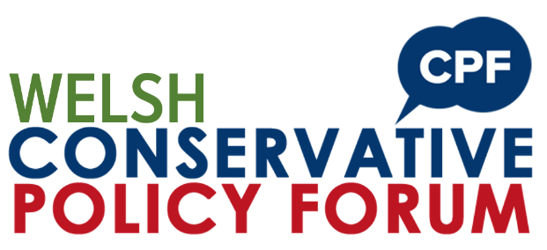

Priorities for the Sixth Senedd: August 2021
Consultation Response Form

You can complete the consultation online at conservatives.wales/cpf-august-21 or email this form to dc.political@welshconservatives.com by midnight 29th August 2021.
Please complete your details below:
Name
Constituency
Email
Telephone
The Conservative Party uses the information you provide for the purposes of democratic engagement. This covers a wide range of activities inside and outside election periods, including but not limited to: democratic representation; communicating with you; surveying and opinion gathering, campaigning activities; activities to increase voter turnout; supporting the work of elected representatives, prospective candidates and official candidates; and fundraising to support any of these activities. For full terms of use and how to exercise your rights see our Privacy Notice at www.conservatives.wales/privacy.
Responses to Questions
Question 1:
What do you think are the top priorities the Welsh Conservatives should campaign on over the next five years?
Text…

Question 2:
How would you tackle your top three issues, aside from Covid-19, impacting Wales at the moment?
Text…

Question 3:
What action would you take to deliver better health outcomes in Wales?
Text…

Question 4:
What changes would you implement to ensure that Local Government is able to deliver effectively for local communities?
Text…

Question 5:
How would you reduce carbon emissions in Wales by 2050? What are the issues that may prevent Wales from achieving this?
Text…

If you need any support please email dc.political@welshconservatives.com or call 02920 736562.
Submit your response by midnight 29th August 2021.
Thank you.

